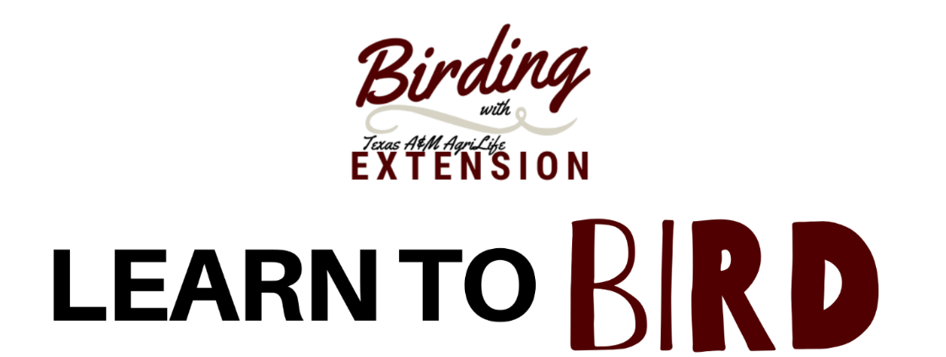
West Texas – October 8 – 11, 2021
East Texas – October 13 – 15, 2021

Master Naturalist AT Request Information
AT hours recommended: 12 hours

Please have your AT committee review and approve. Questions? Please email Dr. Maureen Frank at mgfrank@tamu.edu
Friday
6:00 – 8:00 PM Welcome Dinner and Birding 101 1 hour

Saturday
8:00 – Noon Focused Birding/Bird Identification 4 hours

2:00 – 4:00 PM Learn to Bird Classroom Presentations 2 hours
- Backyard Bird Management – (1.5 hours)
- Basics of Bird Photography – (.5 hours)

After dark Owl Identification 1 hour

Sunday
8:00 – 12 PM Focused Birding/Bird Identification 4 hours

